eTools - Sales Project Design

# ERD for UX process

Place your ERD diagram here.

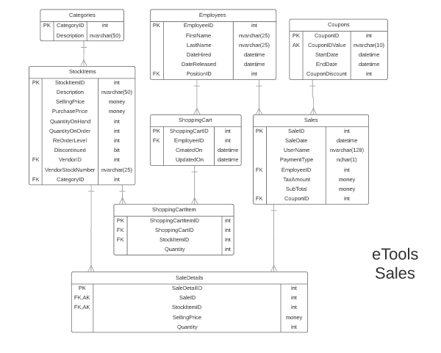

# Possible UX Interface

Place your screen design(s) here

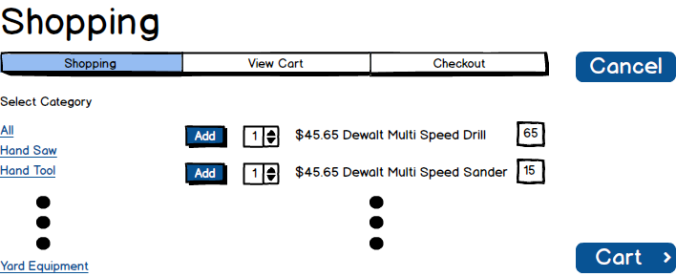

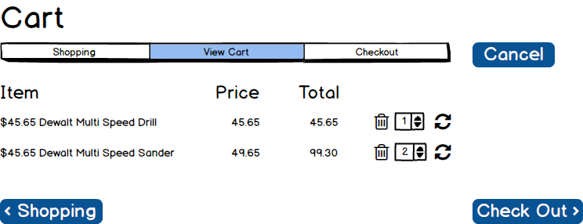

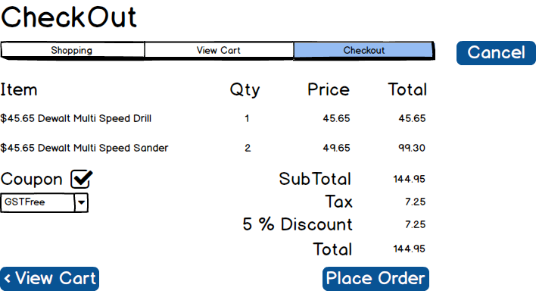 `

# Event and Wiring Summations

|  |  |  |
| --- | --- | --- |
| **Controls** | | **Events** |
| CategoryDDL | | None / wired via ObjectDataSource |
| **BBL Class(es) and Method (s)** | | |
| CategoryController | List<CategoryList> List_Category()  Retrieve a list of Category titles and category id for DDL  List<CategoryList> List_All_Category()  Retrieve a list of all Category titles and category id for DDL | |
| **SQL Table(s): (C,R,U,D)** | | **Entities/DTOs/POCOs** |
| Categories (R) | | CategoryList (P) |

|  |  |  |
| --- | --- | --- |
| **Controls** | | **Events** |
| Cart(ShoppingCart), ShoppingCartItemID, StockItemID, Quantity | | Cart OnClick   * Validate date present; * Call BLL; * Bind returned data to ProductList |
| **BBL Class(es) and Method (s)** | | |
| CategoryProductsController | List< ShoppingCartItems > List_ProductsForShoppingCart(int shoppingcartid, string username)  Retrieve a list of products for supplied shoppingcart id and username. Return stockitemid, name, price, total, quantity. Display in Shopping Cart (productlist). | |
| **SQL Table(s): (C,R,U,D)** | | **Entities/DTOs/POCOs** |
| ShoppingCart (R), ShoppingCartItems (R), StockItems(R) | | ShoppingCartItemsStockItems (P) |

|  |  |  |
| --- | --- | --- |
| **Controls** | | **Events** |
| Save ( ShoppingCart ), ShoppingCartItemID , StockItemID, Quantity | | Save OnClick   * Collect stockitems from ShoppingCartItems and ShoppingCartItemsID; * Send to BLL for saving; |
| **BBL Class(es) and Method (s)** | | |
| CategoryProductsController | Void Update_ProductsForShoppingCart(int shoppingcartid, int shoppingitems, string username, List< ShoppingCartProduct > ) | |
| **SQL Table(s): (C,R,U,D)** | | **Entities/DTOs/POCOs** |
| ShoppingCart (U), ShoppingCartItems (U) | | ShoppingCartItemsStockItems (P) |

|  |  |  |
| --- | --- | --- |
| **Controls** | | **Events** |
| Add: Add sign, ShoppingCartID, ShoppingCartItemID | | OnCommand   * Collect stockitems information; * Send to BLL for adding stockitem to shoppingcartitems; * Refresh shoppingcartitems |
| **BBL Class(es) and Method (s)** | | |
| CategoryProductsController | Void Add_ProductsToShoppingCart(int shoppingcartid, int shoppingitems, string username, List< ShoppingCartProduct > ) | |
| **SQL Table(s): (C,R,U,D)** | | **Entities/DTOs/POCOs** |
| ShoppingCart (C), ShoppingCartItems (C) | |  |

|  |  |  |
| --- | --- | --- |
| **Controls** | | **Events** |
| Delete: Delete sign, ShoppingCartID, ShoppingCartItemID | | OnClick   * Collect track id, stockitemsid, shoppingcartid, shoppingcartitemsid; * Send to BLL for remove stockitem from shoppingcartitems; * Refresh shoppingcartitems |
| **BBL Class(es) and Method (s)** | | |
| CategoryProductsController | Void Remove_ProductsToShoppingCart(int shoppingcartid, int shoppingitems, string username, List< ShoppingCartProduct > ) | |
| **SQL Table(s): (C,R,U,D)** | | **Entities/DTOs/POCOs** |
| ShoppingCart (R), ShoppingCartItems (R/D) | |  |

|  |  |  |
| --- | --- | --- |
| **Controls** | | **Events** |
| CouponsDDL | | None / wired via ObjectDataSource |
| **BBL Class(es) and Method (s)** | | |
| CouponController | List<CouponList> List_Coupon()  Retrieve a list of Category titles and category id for DDL | |
| **SQL Table(s): (C,R,U,D)** | | **Entities/DTOs/POCOs** |
| Coupons (R) | | CouponsList (P) |

Comments

You are missing the event for Place. This is a very criterial event. It does the final recording of the sale. Also you have changed the coupon process. The user presents the coupon and it is verified by clicking the checkmark. You will need to change this. What happens if the coupon is good (missing form details)? You seem to understand the high level workings of the subsystem but are lacking the details on the processing. You need to firm up these details.